**Access Points and Parameters for Web Services  
  
Summary**  
  
UN Comtrade Web Services site is <http://comtrade.un.org/ws>. To construct a proper web service request, append the web services site with access points and combine them with (query string) parameters.  See example section below.  
  
Table: UN Comtrade Web Services Access Points and its Parameters   
  
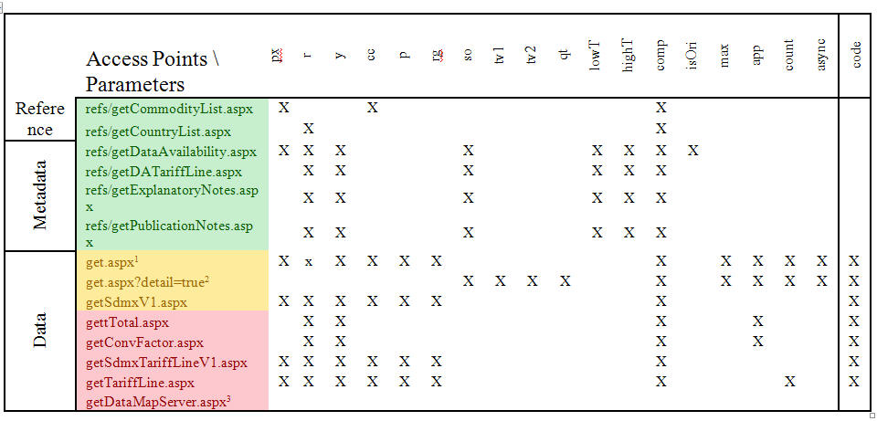  
1) All commodity wild cards work except AG; no advance filter.  
2) Fully compatible with Basic/Express selection.  
3) Used for UN Comtrade only.  
  
Free access points highlighted in green, subscriber only access points in yellow, and restricted access points in red.  
  
**Access Points**

|  |  |
| --- | --- |
| **Access Points** | **Descriptions** |
| refs/getCommodityList.aspx | Get list of commodity |
| refs/getCountryList.aspx | Get list of country |
| refs/getDataAvailability.aspx | Get data availability |
| refs/getDATariffLine.aspx | Get tariff line data availability |
| refs/getExplanatoryNotes.aspx | Get explanatory notes |
| refs/getPublicationNotes.aspx | Get publication notes |
| get.aspx | Get data in element-based XML format |
| get.aspx?detail=true | Get data in element-based XML format |
| getSdmxV1.aspx | Get data in SDMX version 1.0 format |
| gettTotal.aspx | Get Total Trade in XML format |
| getConvFactor.aspx | Get Conversion Factor in XML format |
| getSdmxTariffLineV1.aspx | Get Tariff line data in SDMX version 1.0 format |
| getTariffLine.aspx | Get Tariff line data in XML format |
| getDataMapServer.aspx | Get data in GML format |

**Parameters**

|  |  |  |
| --- | --- | --- |
| **Parameters** | **Descriptions** | **Possible Values** |
| px | Commodity Classifications | HS, H0-H4, ST, S1-S4, BE |
| r | Reporting Countries | UN Comtrade Country Codes or Country Groups |
| y | Years | 4 digits year |
| cc | Commodity Codes | Commodity Codes, with wild cards or Commodity Groups |
| p | Partner Countries | UN Comtrade Country Codes or Country Groups |
| rg | Trade Flow | Number 1 to 4 |
| so | Sort Order | See below |
| tv1 | Comparison Sign | See below |
| tv2 | Comparison Value | See below |
| qt | Aggregation Option | y or n |
| lowT | Start Date / Time | Date format YYYY-MM-DD |
| highT | End Date / Time | Date format YYYY-MM-DD |
| comp | Data Compression | true or false |
| isOri | Reported/Converted Data | true or false |
| max | Max returned records | Number |
| app | Application Identifier | Any text (optional) |
| count | To count no of records | true or false |
| async | Asynchronous Web Call | true or false; see related KB articles |
| code | Authorization Code | Use for off-site web services access.  Can be obtained from http://comtrade.un.org/db/u/uAccountInfo.aspx |

**Additional information:**  
  
so= pre-defined sort order ; possible values  
"1" Year;Flow;Rep;Comm;Ptnr;  
"2" Year;Rep;Flow;Comm;Ptnr;  
"3" Flow;Year;Rep;Comm;Ptnr;  
"4" Flow;Rep;Year;Comm;Ptnr;  
"5" Rep ;Year;Flow;Comm;Ptnr;  
"6" Rep ;Flow;Year;Comm;Ptnr;  
"7" Comm;Year;Flow;Rep ;Ptnr;  
"8" Comm;Year;Rep ;Flow;Ptnr;  
"9" Comm;Flow;Year;Rep ;Ptnr;  
"10" Comm;Flow;Rep ;Year;Ptnr  
"11" Comm;Rep ;Year;Flow;Ptnr;  
"12" Comm;Rep ;Flow;Year;Ptnr;  
"13" Year;Flow;Rep;Comm;TradeVal;  
"14" Year;Rep;Flow;Comm;TradeVal;  
"15" Flow;Year;Rep;Comm;TradeVal;  
"16" Flow;Rep;Year;Comm;TradeVal;  
"17" Rep ;Year;Flow;Comm;TradeVal;  
"18" Rep ;Flow;Year;Comm;TradeVal;  
"19" Comm;Year;Flow;Rep ;TradeVal;  
"20" Comm;Year;Rep ;Flow;TradeVal;  
"21" Comm;Flow;Year;Rep ;TradeVal;  
"22" Comm;Flow;Rep ;Year;TradeVal  
"23" Comm;Rep ;Year;Flow;TradeVal;  
"24" Comm;Rep ;Flow;Year;TradeVal;  
"1001" TradeVal;  
"9999" --None--  
  
For an example, so=13 will order the result by year, flow, reporter, commodity and value  
  
Filter Trade value, use tv1 and tv2  
tv1=comparison sign:  
0"Greater Than Equal  
1"Greater Than  
2"Less Than Equal  
3"Less Than  
tv2= comparison value in US$  
  
For an example, tv1=0&tv2=1000000000 will filter the result for trade value >= 1 billion US$  
  
Aggregation option  
qt=n or qt=y. If qt set to n, the system will keep the quantity differences during the on-fly commodity aggregation.  
 **Example**  
The easiest to learn the query string is to copy query string from UN Comtrade web site during the data selection (<http://comtrade.un.org/db/dqQuickQuery.aspx>), Then just add them to web access points (don’t forget to add comp=false)

http://comtrade.un.org/ws/getSdmxV1.aspx?cc=TOTAL&px=H2&r=372&y=2006&comp=false&code=E7IVCVPPBt6P1dbTLNki6KG+DWOfoCs9b/mSFUmu3rvpUbLWusXmry7DsbeZoJHaVKIPzlQ7WC0sYwuqDumDua5yLOdJt4602MJMWhhjP3s8+rXCLBtar9w6pXRMhrJ2Fdj4NwzSSvrrlc3QHxjYzkGrnDHFZAqLtqK+S1hJs1w=

Px = Commodity Classification

R = Reporter

Y = Year

CC = Commodity Code

P = Partner Country

Rg = Trade Flow

-Get 2 digit HS1996: http://comtrade.un.org/ws/refs/getCommodityList.aspx?px=H1&cc=??

-Get all country codes: http://comtrade.un.org/ws/refs/getCountryList.aspx

Query string parameters:

px (classification), r (reporter codes), y (years), lowT (start date), highT (end date), so (sort order), isOri (original flag).

Possible Parameter Values:

Available classifications (px): HS2002 (H2), HS1996 (H1), HS1988 (H0), SITC Rev.3 (S3), SITC Rev.2 (S2), SITC Rev.1 (S1), BEC (BE)